* First u need to download the Branch Backoffice from the following path,

<http://www.geojit.net/GBNPP2016/downloads/downloads.asp>

Latest version is : 1.02.19

* Branch BackOffice Account Opening Path:

BRGBNPP2016-->Transaction-->Definition-->Transaction-->Client Master (Scan Based Account Opening)

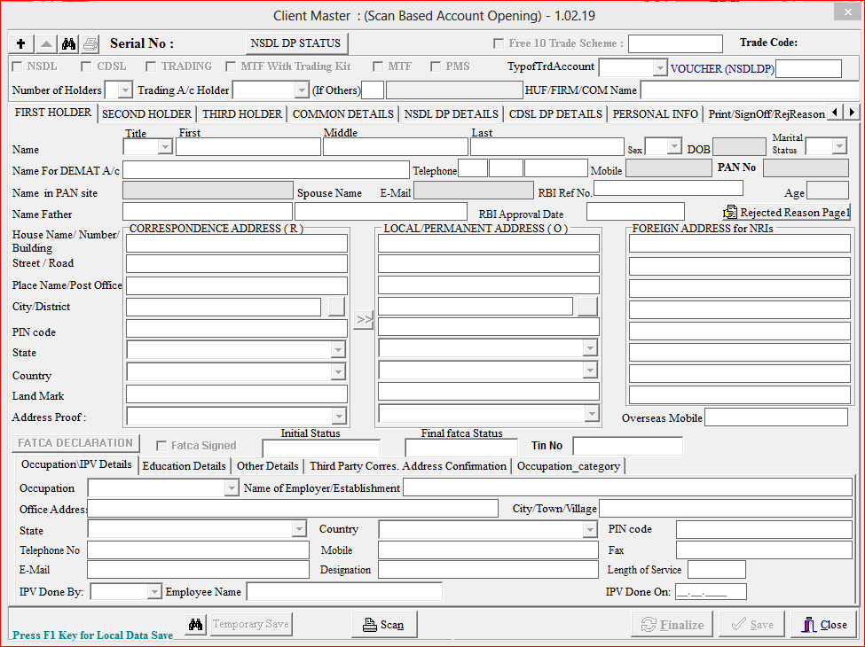

When click on Add button in the top Left corner, another form ‘Primary Verification Details’ will appear:

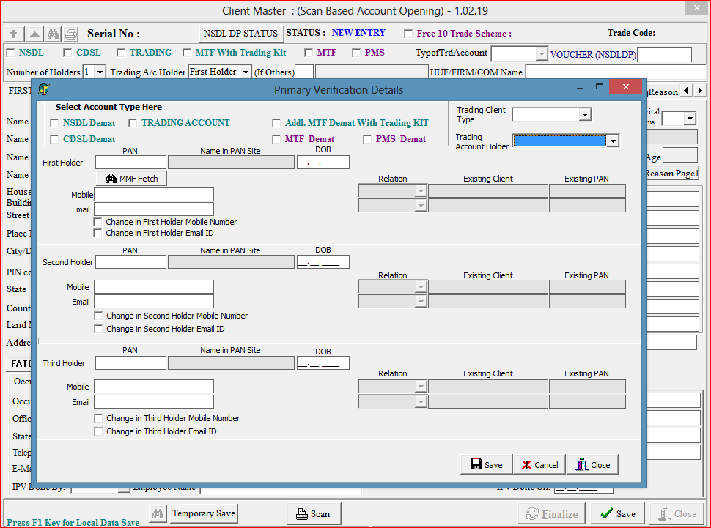

If the Login user Location is MMF, ’MMF Fetch’ button will appear below the first holder pan, where we can fetch the details of client using Pan/Name.

After saving the primary verification details, the data fetched from the table MMFIDB.dbo.mmf_investor_registration_data_tb of selected client will be automatically filled in main form.